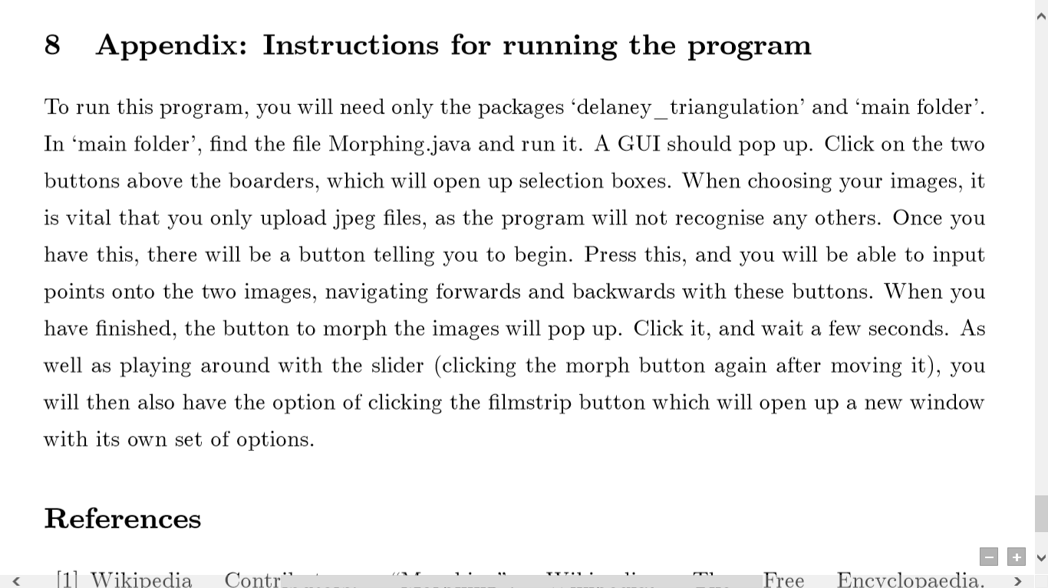

When you save an image in the program, it will be sent to the directory you have the application in. The program should work fine on any computer, but if there are any problems on a larger size computer, switch to a laptop.